Specialized Lexicon

What is Specialized Lexicon
# Source: Chatgpt (GPT-4-turbo) at [7/29/2025]
A Specialized Lexicon is a collection of technical or field-specific vocabulary used within a particular academic, professional, or technical domain. Unlike general-purpose lexicons, specialized lexicons focus on precision and relevance to subject matter experts or professionals.

🔹 Key Features of a Specialized Lexicon
# Source: Chatgpt (GPT-4-turbo) at [7/29/2025]
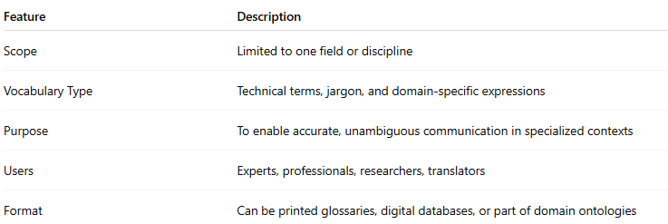
Feature | Description
Scope | Limited to one field or discipline
Vocabulary Type | Technical terms, jargon, and domain-specific expressions
Purpose | To enable accurate, unambiguous communication in specialized contexts
Users | Experts, professionals, researchers, translators
Format | Can be printed glossaries, digital databases, or part of domain ontologies

🔹 Examples of Specialized Lexicons
# Source: Chatgpt (GPT-4-turbo) at [7/29/2025]
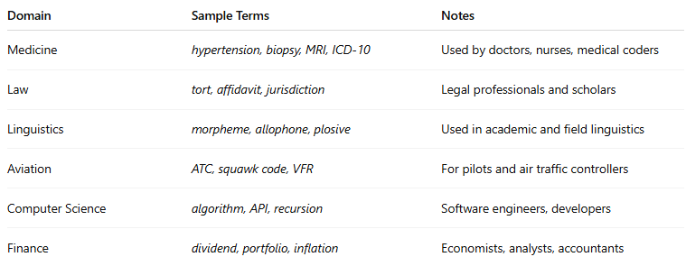
Domain | Sample Terms | Notes
Medicine | hypertension, biopsy, MRI, ICD-10 | Used by doctors, nurses, medical coders
Law | tort, affidavit, jurisdiction | Legal professionals and scholars
Linguistics | morpheme, allophone, plosive | Used in academic and field linguistics
Aviation | ATC, squawk code, VFR | For pilots and air traffic controllers
Computer Science | algorithm, API, recursion | Software engineers, developers
Finance | dividend, portfolio, inflation | Economists, analysts, accountants

🔹 Specialized vs General Lexicon
# Source: Chatgpt (GPT-4-turbo) at [7/29/2025]
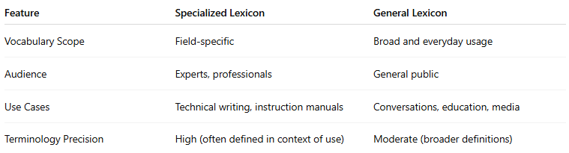
Feature | Specialized Lexicon | General Lexicon
Vocabulary Scope | Field-specific | Broad and everyday usage
Audience | Experts, professionals | General public
Use Cases | Technical writing, instruction manuals | Conversations, education, media
Terminology Precision | High (often defined in context of use) | Moderate (broader definitions)

Specialized vs Domain-Specific Lexicon vs General Lexicon

🔹 Comparison Table
# Source: Chatgpt (GPT-4-turbo) at [7/29/2025]
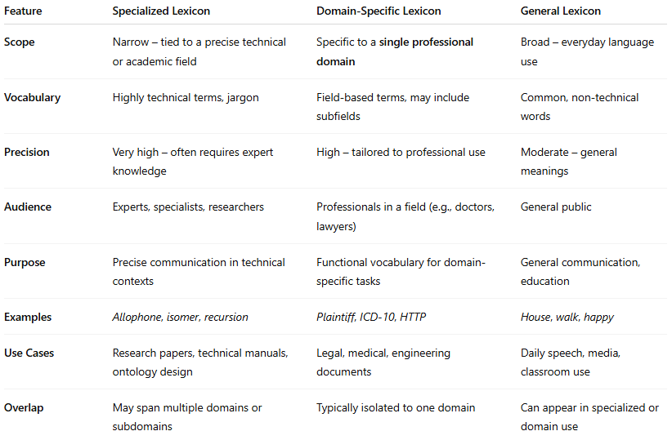

Feature | Specialized Lexicon | Domain-Specific Lexicon | General Lexicon
Scope | Narrow – tied to a precise technical or academic field | Specific to a single professional domain | Broad – everyday language use
Vocabulary | Highly technical terms, jargon | Field-based terms, may include subfields | Common, non-technical words
Precision | Very high – often requires expert knowledge | High – tailored to professional use | Moderate – general meanings
Audience | Experts, specialists, researchers | Professionals in a field (e.g., doctors, lawyers) | General public
Purpose | Precise communication in technical contexts | Functional vocabulary for domain-specific tasks | General communication, education
Examples | Allophone, isomer, recursion | Plaintiff, ICD-10, HTTP | House, walk, happy
Use Cases | Research papers, technical manuals, ontology design | Legal, medical, engineering documents | Daily speech, media, classroom use
Overlap | May span multiple domains or subdomains | Typically isolated to one domain | Can appear in specialized or domain use

🔸 Key Distinctions
# Source: Chatgpt (GPT-4-turbo) at [7/29/2025]
- Specialized Lexicon is the most technical: it often includes terms that require field-specific training to understand (e.g., terms in neurosurgery, theoretical physics, computational linguistics).
- Domain-Specific Lexicon is broader but still professional: used in specific industries or knowledge domains, such as law or medicine, but may include some general-use items used differently.
- General Lexicon is what you’d find in daily conversations, media, or basic-level dictionaries. It is not tied to a profession or field.

🔸 Visual Analogy
# Source: Chatgpt (GPT-4-turbo) at [7/29/2025]
Think of them like concentric circles:
- General Lexicon = the outermost, widest circle (used by everyone)
- Domain-Specific Lexicon = a circle inside (used by professionals in a field)
- Specialized Lexicon = the innermost circle (used by experts and researchers)

🔹 Applications
# Source: Chatgpt (GPT-4-turbo) at [7/29/2025]
- Translation and interpreting in specialized fields
- Technical documentation and manuals
- AI/NLP training in domain-specific contexts
- Academic publishing and field-specific research
- Terminology management in multilingual environments

